

www.globalsight.com

**GlobalSight Selenium Automation**

Author：Leon.Song

Contents

Document Description 3

Environment Setup 4

Develop Environment(Eclipse+TestNG+Selenium): 4

Selenium Server and Firefox configuration 6

CVS Server configuration 13

Structure 14

Framework 14

Source structure 15

Run Automation 18

Coding 19

Stores of knowledge 20

Other 20

|  |  |  |  |
| --- | --- | --- | --- |
| **Date** | **Description** | **Version** | **Author** |
| 2010/07/26 | Create(according exist document, author: Jester and Jessie) | 0.1 | Leon Song |

# Document Description

This document is used to guide:

1. How to deploy the automation environment with Selenium, eclipse, Test NG, Ant, Firefox and other tools.
2. Configuration about the tools
3. Description of the framework
4. How to do the secondary development

# Environment Setup

## Develop Environment(Eclipse+TestNG+Selenium):

1. Install the JDK with the latest version.
2. Download the Eclipse classic version and extract it.
3. Install the TestNG in the eclipse.
4. In the eclipse, click “help->software updates”.
5. Click “Available Software->Add Site”, input the <http://beust.com/eclipse> in the “Location” input box.
6. Click “OK”, select the “testng” and follow the prompt.
7. When finished, restart the eclipse.
8. Copy the selenium folder “selenium-2.0b3.zip” to the plugins folder of eclipse and unzip it.
9. Add the selenium client jars to the project “Build Path”.
10. Checkout selenium source code from CVS Server - \GlobalSightSource\main6\QA_Automation\Selenium
11. Create a new project in Eclipse(File->New->Java Project), input a name and point the location.

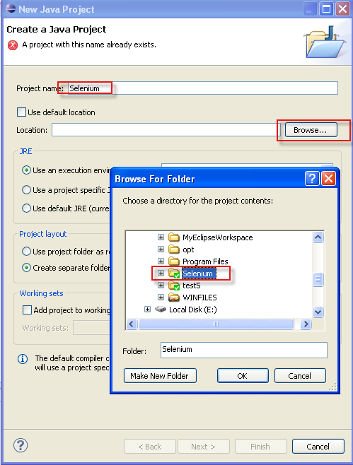

Click Next, Finish, after that, the project crated like below:

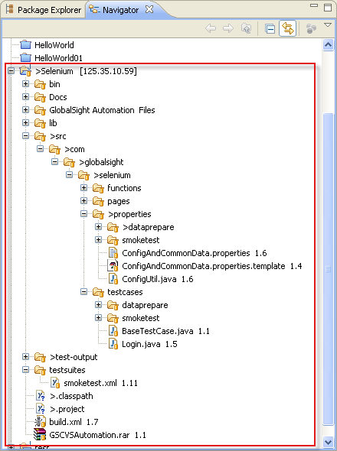

## Selenium Server and Firefox configuration

Notes：It’s recommended to run the testcases with firefox 3.x

1. Copy the selenium folder “selenium-2.0b3.zip” to the one system (where you want to run automation) folder and unzip it. For example(C:\selenium-2.0b3)

Copy the directory “GlobalSight Automation Files” to the system (the directory is in the source project in eclipse), for example (C:\GlobalSight Automation), and share the directory, the files in this directory are used for running automation.

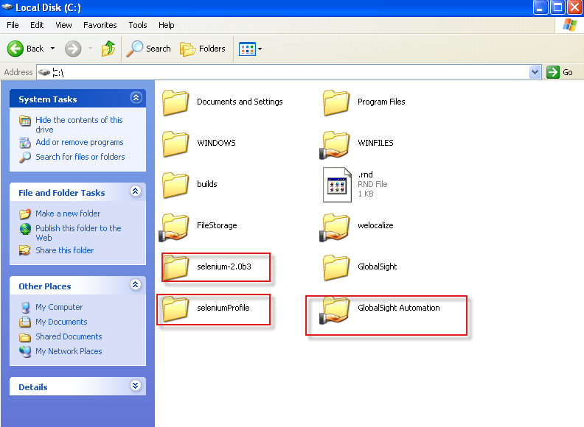

1. Open “cmd” command, navigate to firefox installation directory, and input “firefox -p”

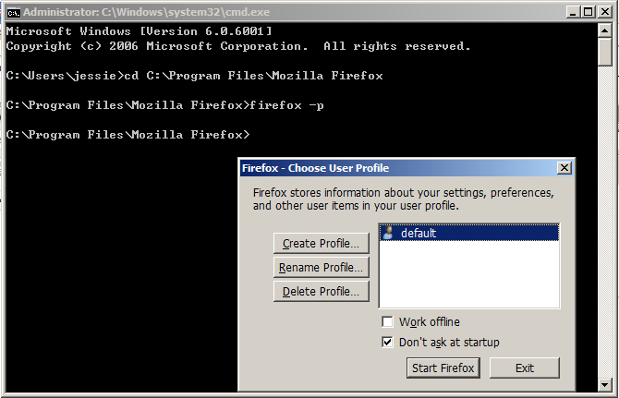

1. Click Create Profile…

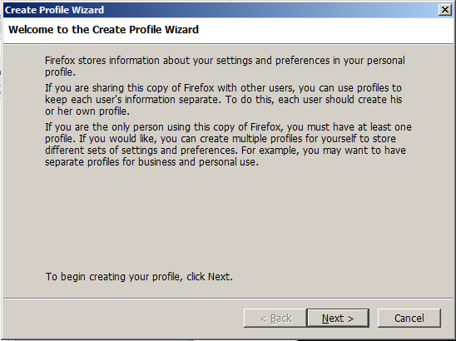

1. Click next button, input a new profile name, like “selenium”. Select a file folder for example(C:\seleniumProfile) and Then Click Finish

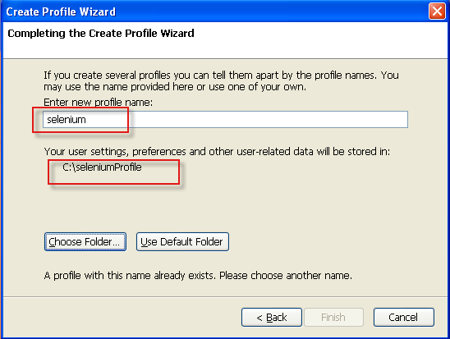

1. Click Start Firefox with newly created firefox profile.

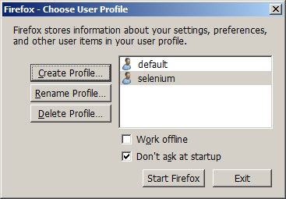

1. Set the default download location with options –

“Save files to” is the folder you created in step 1

C:\GlobalSight Automation Files\ResultFiles

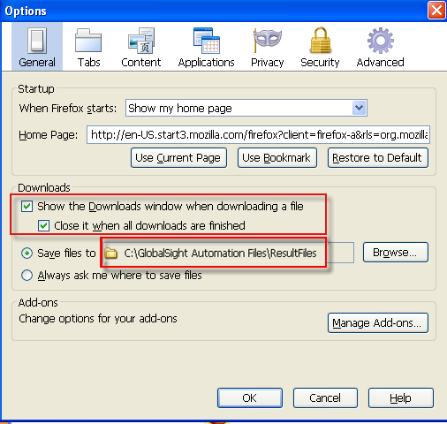

To make sure Firefox could download file without any dialog, you should make the configurations as below:

Log one GlobalSIght Server and export some file, set the options like

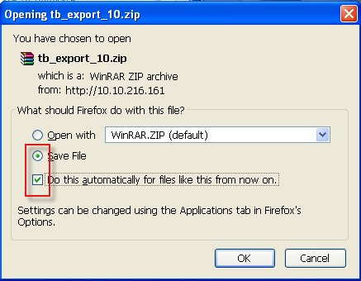

This operation must be done for all the downloaded format files in our automation test case.

Make sure all downloaded file format listed in the Applications with Save File. Like below

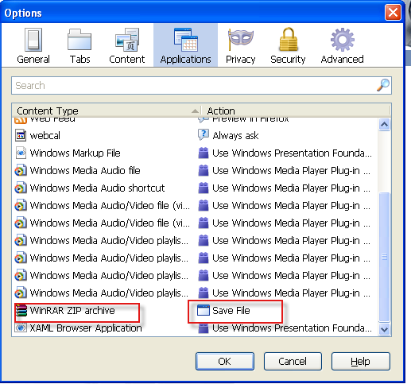

After that, you can close firefox.

1. Run the server.

Run the command “cmd”, the run the command as below:

“java -jar <Server Path> -firefoxProfileTemplate <firefox profile path> -port <port>”

for example:

java -jar C:\selenium-2.0b3\selenium-server-standalone-2.0b3.jar -firefoxProfileTemplate C:\seleniumProfile -port 3333

## CVS Server configuration

CVS Server will be used when run the CVS Job Test Case.

1. Copy the CVS Server VM image and open it, get the IP
2. Run the CVS Server
3. Edit the properties about CVS in the ConfigAndCommonData.properties file.

CVSServer_HOST=10.10.216.195(we can only change this property)

CVSServerRepositoryName=CVSTest

CVSServerUserName=jessie

CVSServerUSerPassword=password

Sandbox=sandBox

# Structure

## Framework

All the test case for smoke test have been finished, and maybe the coupling is very high, but as discussed with Jessie, there is no need to change the data except big change for GlobalSight.

Next stage is matrix or bug suit, for these three suits, all the data will not rely on the data of each other, the effect is that you can run any one suit as you need. Also we can run the test suits with different server, maybe this can save some time.

Picture 01 and 02 as below

Picture01

Picture02

Side-by-side for multiple test suits

## Source structure

Below is the structure of our source code.

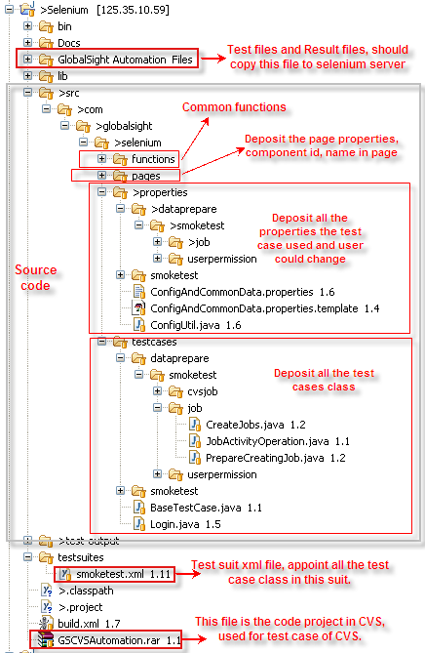

Several place need to emphasize

1. “GlobalSight Automation Files” directory should be copied to selenium server and be shared. In Selenium Server, “ResultFiles” is the directory where Firefox download files to. And all the test files are in “TestFiles” directory.

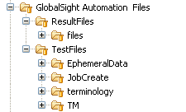

1. functions

All the common functions are in this package. The “downloadfileread” package saves the methods for read/manage the loaded files in Selenium Server from GS by Firefox. The “ephemeraldata” package saves the methods for save/read ephemeral data in the progress of running test cases. When develop the test case, we can find the method you need, and if other common method could be added to this package if need.

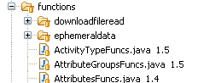

1. pages

Used to saving all the pages, contains the id/name… of the element.

1. testcases

All the test cases are in this package.

All the prepare data progress case are in “dataprepare” package, for example, All the classes in “testcases/dataprepare/smoketest” are used for preparing data for the case in “testcases/smoketest” package. If we want to add a new suit named with “matrix”, we can build like the third picture.

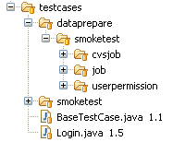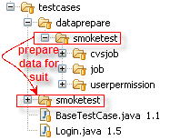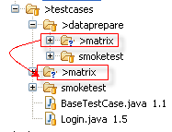

Data prepare is only used for preparing data, it has no check points. All the test cases in the suit(like “testcases/smoketest”) have check points.

1. properties

The “properties” package is used for saving the properties that test case used, and all the properties file are correspondence to the test case class in “testcases” package,you can edit the properties file as you need, for example TM Name and option you need.

Note: All the configuration and common data are saved in the file (ConfigAndCommonData.properties), for example: GS Server ip, Selenium Server ip…

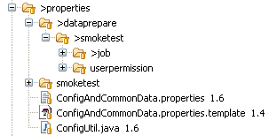

1. test-output

This directory is used for saving the result report of running test case that generated by Test NG when we run build.xml.

1. testsuits

This directory defined all the test suits, it organizes all the test case classes. We can run any one test suit here, run as test NG. The order of the test cases classes is very important.

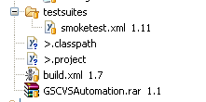

1. build.xml

This file is very important, it organizes the test suits. We can run this xml file with ANT.

1. GSCVSAutomation

This file is used for CVS Job test case. If we need to make a new CVS Server, we should make a new module with this directory in CVS.

# Run Automation

**Prepare:**

1. Make sure the environment have been deployed(Eclipse+TestNG+Selenium, Selenium Server, Firefox configuration, CVS Server…)
2. Edit “ConfigAndCommonData.properties”, this properties file is very important, you must specify the server IP…, for example as below:

######################System configuration######################

######GlobalSight Server############

SERVER_URL = http://10.10.216.161:80

######SELENIUM Server###############

SELENIUM_HOST = 10.10.216.161

SELENIUM_PORT = 3333

######Base_Path:save the test files, the directory is in SELENIUM Server######

Base_Path = \\\\10.10.216.161\\GlobalSight Automation\\TestFiles\\

######Base_Path_Result:save the result files from GlobalSight(i.e. TB export files), the directory is in SELENIUM Server########

Base_Path_Result = \\\\10.10.216.161\\GlobalSight Automation\\ResultFiles\\

######BROWSER:Browser type to run automation######

BROWSER = *firefox

######other configuration############

……

1. Other properties need to edit according to your test need.

**Run:**

1. In Eclipse, right click the “smoketest.xml” file and select “run as🡪 TestNG Suite”. Or you can right click the “Build.xml” and select “run as->Ant Build”.Also, debug is ok.
2. You can check the result at the “test-output” folder.
3. You can find the loaded files (exported file or snapshot) in “GlobalSight Automation Files” directory in Selenium Server.

# Coding

1. Naming rules：
2. Add a suffix “BUTTON” to Button definition. Such as “OK_Button=’ok’”.
3. Add a suffix “MENU” or “SubMenu” to menu definition.
4. Add a suffix “CHECKBOX” to Check Box definition.
5. Add a suffix “RADIO” to Radio Button definition.
6. Add a suffix “TEXT_FIELD” to Text Field definition.
7. Add a suffix “TEXT” to Text Box definition.
8. Add a suffix “LABEL” to Label definition.
9. Add a suffix “SELECT” to select definition.
10. Data design

When you design the data you used in test suit, you should according to old data.

1. Package, Method

Make sure put class to corresponding package. Please use exist method if you can use to avoid repeatability.

# Stores of knowledge

1. Java, basic coding
2. Selenium API
3. CVS operation, merge/commit/add/update…
4. Eclipse, Test NG, Ant
5. Knowledge of GloabalSight

# Other

This document will be updated according matrix and bug…

Any problems please let me know

-----------Leon